Proposed API Endpoints
Five endpoints form the core of the Limkokwing Library Digital System API:
Method | Endpoint | Purpose | Input | Output
GET | /books | Search books by title, author, or category | ?title=Python or ?author=Lutz | {"status":"success","results":  [{"book_id":"B101","available"  :true}]}
POST | /borrow | Allow a user to borrow an available book | {"user_id":"U55",  "book_id":"B101"} | {"status":"borrowed",  "due_date":"2026-05-28"}
POST | /return | Allow a user to return a borrowed book | {"user_id":"U55",  "book_id"  :"B101"} | {"status":"returned","fine":0.00}
GET | /overdue | Track overdue books and calculate fines | ?user_id=U55  (optional) | {"overdue_books":  [{"days_overdue":18,"fine":9.00}]}

Architecture Diagram: Client → API → Server

Implementation
Python Script:
import asyncio
from datetime import date, timedelta
from typing import Optional

# ---- Simulated Database ----
books_db: dict[str, dict] = {
"B101": {"title": "Learning Python", "author": "Mark Lutz", "available": True},
"B202": {"title": "Clean Code", "author": "Robert Martin", "available": True},
}
loans_db: dict[str, dict] = {}
fines_per_day: float = 0.50

async def get_books(query: str) -> dict:
"""GET /books"""
await asyncio.sleep(0.1)
results = [{**info,'book_id':bid} for bid,info in books_db.items()
if query.lower() in info['title'].lower()
or query.lower() in info['author'].lower()]
return {"status":"success","count":len(results),"results":results}

async def borrow_book(user_id: str, book_id: str) -> dict:
"""POST /borrow"""
await asyncio.sleep(0.2)
if book_id not in books_db:
return {"status":"error","message":"Book not found"}
if not books_db[book_id]['available']:
return {"status":"error","message":"Book is currently unavailable"}
books_db[book_id]['available'] = False
due = date.today() + timedelta(days=14)
loans_db[f"{user_id}_{book_id}"] = {"user_id":user_id,"book_id":book_id,
"borrow_date":str(date.today()),"due_date":str(due)}
return {"status":"borrowed","due_date":str(due),"message":"Book borrowed successfully"}

async def return_book(user_id: str, book_id: str) -> dict:
"""POST /return"""
await asyncio.sleep(0.2)
key = f"{user_id}_{book_id}"
if key not in loans_db:
return {"status":"error","message":"No active loan found"}
loan = loans_db.pop(key)
books_db[book_id]['available'] = True
due = date.fromisoformat(loan['due_date'])
days = max(0,(date.today()-due).days)
fine = round(days*fines_per_day,2)
return {"status":"returned","overdue_days":days,"fine_usd":fine,
"message":"Returned on time" if fine==0 else f"Fine of ${fine} applied"}

async def check_overdue(user_id=None) -> dict:
"""GET /overdue"""
await asyncio.sleep(0.1)
today,overdue = date.today(),[]
for loan in loans_db.values():
if user_id and loan['user_id']!=user_id: continue
due=date.fromisoformat(loan['due_date']); days=(today-due).days
if days>0: overdue.append({**loan,'days_overdue':days,'fine':round(days*fines_per_day,2)})
return {"status":"success","overdue_count":len(overdue),"overdue_books":overdue}

async def main():
print("=== Limkokwing Library API Simulation ===\n")
print(await get_books("python"))
results = await asyncio.gather(borrow_book('U01','B101'),borrow_book('U02','B202'))
for r in results: print(r)
print(await borrow_book('U03','B101')) # conflict test
print(await return_book('U01','B101'))
print(await check_overdue())

if __name__ == '__main__': asyncio.run(main())

Output:
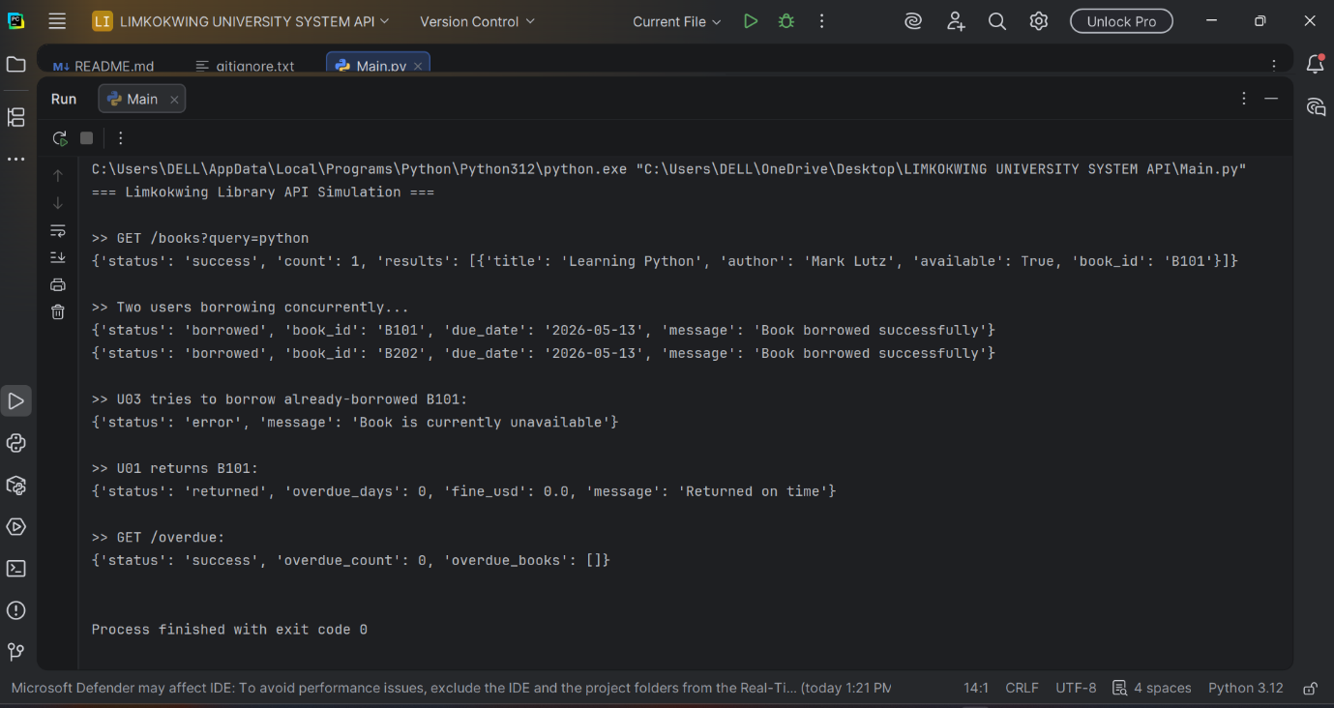

Reflection

How APIs Improve Efficiency in Limkokwing Library Services
APIs make library services significantly more efficient by automating manual processes. Instead of physically checking shelves or paper records, a single API call instantly returns availability, borrower history, and fine amounts in real time. Multiple users can query or borrow books simultaneously without waiting, because the API handles concurrent requests through asynchronous programming — as demonstrated with asyncio.gather() above. APIs also enforce consistent business rules, reducing human error and ensuring fairness for all students.
For Limkokwing specifically, a library API could integrate with the student portal, allowing students to borrow books using their existing credentials without a separate registration, reducing friction for both staff and students.

SDG Alignment – SDG 4: Quality Education
This assignment directly supports SDG 4 by making educational resources more accessible, trackable, and fairly managed for all students regardless of technical skill. A digital library API reduces barriers to learning by enabling quick availability checks, easy borrowing, and automated fine reminders, aligning with the SDG 4 goal of inclusive and equitable quality education.

Challenges Faced
- Handling concurrent requests without data corruption: Solved using async/await and careful shared-state management to prevent race conditions when multiple users borrow simultaneously.
- Structuring consistent JSON responses: Required planning a uniform response format with status, message, and data fields for every endpoint.
- Handling edge cases gracefully: Deciding how to respond to invalid IDs, duplicate borrows, and missing loan records required thorough boundary testing.
- Calculating overdue fines accurately: Ensuring correct date arithmetic so fines are computed only for genuinely overdue books.

Suggested Improvement
If the library expanded, I would add a Reservation / Waitlist endpoint (POST /reserve) so students can queue for unavailable books. On return, the system would automatically notify the next student via email or SMS, preventing repeated availability checks and making the service more proactive at scale.

Conclusion
The Limkokwing Library API shows how a well-designed system using Python and REST principles can improve efficiency by automating book management, enabling real-time access, and supporting multiple users simultaneously. It enhances service delivery while aligning with United Nations SDG 4 by making educational resources more accessible and easier to manage.

